Cse25-391
Student Id:
Student names:
Aobakwe Ronald Kevin Keitemoge
Student email:
Cse25-391@thuto.bac.ac.bw
Cohort:
Group 1-7
Assignment title:
GreenCycle Waste Solution Website
Date of submission:
21/05/2026
Programme of Study:
Computer Systems Engineering
Year of Study:
2025

Intellectual property statement
By checking the box below, I certify that this assignment is my own work and is free from
plagiarism. I understand that the assignment may be checked for plagiarism by electronic or
other means and may be transferred and stored in a database for the purposes of data
matching to help detect plagiarism. The assignment has not previously been submitted for
assessment in any other unit or to any other institution. I
have read and understood the Botswana Accountancy College plagiarism guidelines policy.

Agree Signature……A.R.K.K……………………………….
Date………21/05/26…………………………
MY WEBSITE DOCUMENTATION

1. INTRODUCTION
The internet has become one of the most important communication tools for businesses and organizations. Many companies now use websites to market their services, interact with customers, and improve accessibility to information. A professional website helps businesses increase visibility and build trust with customers.
This project focuses on the design and development of a modern website for Green Cycle Waste Solutions, an environmentally focused company that provides waste management and recycling services. The website was developed using HTML, CSS, Bootstrap, and JavaScript to create a responsive and user-friendly platform.
The website was designed with a clean eco-friendly theme using green colours, modern layouts, animations, image galleries, and responsive navigation. The aim was to create a professional online presence that informs users about the company and its services while encouraging environmental awareness.
Website Objective
The objective of this project is to design and develop a responsive, user-friendly website for a waste management company named GreenCycle. The website aims to provide users with easy access to waste disposal services such as garbage collection, recycling, and dumpster rental.
2. Goals of the Website
- To promote waste management services online
- To allow users to request services easily
- To provide information about recycling and environmental care
- To enhance customer engagement through a feedback system
- To build a professional digital presence for the company
3. Target Audience
The target audience includes:
Demographics:
- Age: 18–60 years
- Location: Urban and suburban areas
- Occupation: Homeowners, business owners, construction companies
Technical Aptitude:
- Basic to intermediate internet users
- Comfortable using mobile phones and web browsers
4. Type of Website
The website is a service-based business website focused on:
- Informational content
- Service booking
- Customer interaction (feedback form)

5. INFORMATION DESIGN & TAXONOMY
Site Map (Structure)
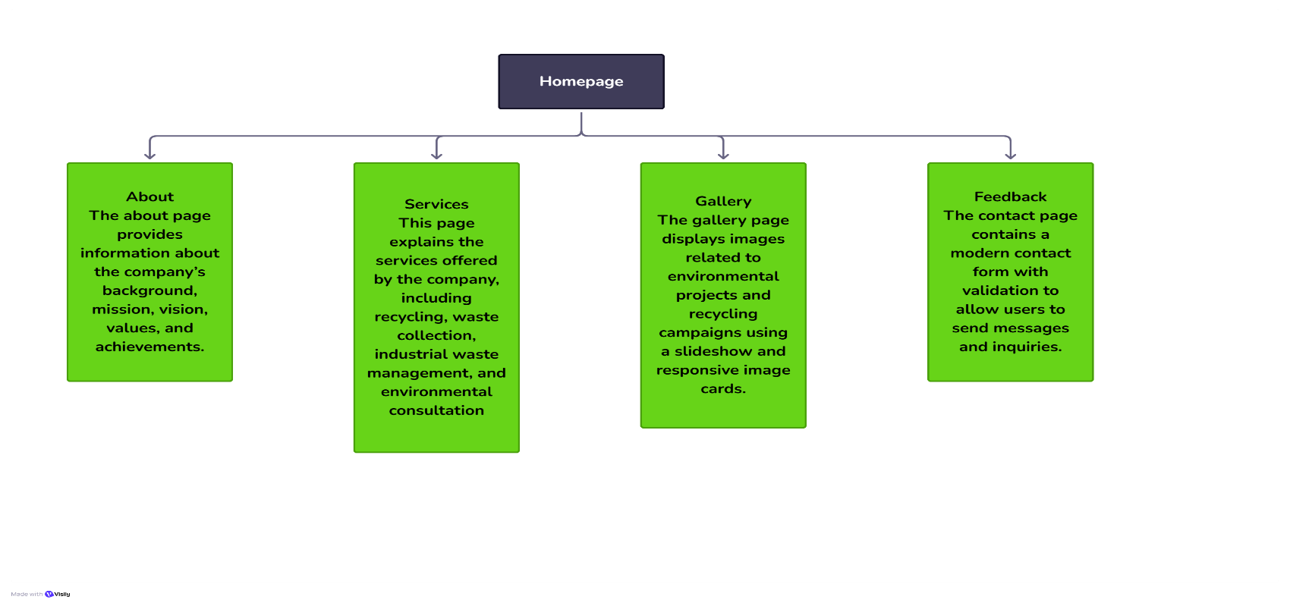
Navigation Structure
- A consistent navigation bar is used across all pages
- Users can access any page within 3 clicks (3-click rule applied)
Content Categorization
- Home → Overview and highlights
- Services → Detailed offerings
- Gallery → Visual content
- About → Company information
- Feedback → User interaction

6. PAGE TEMPLATE DESIGN
Layout Structure
Each page follows a consistent layout:
- Header (Navigation bar)
- Hero Section (Banner)
- Content Sections
- Footer
Design Features
- Clean and modern interface
- Use of whitespace for readability
- Grid-based layout (Bootstrap)
- Consistent color scheme (green, white, dark tones)
WIREFRAME :LOW FIDILITY
HOMEPAGE:
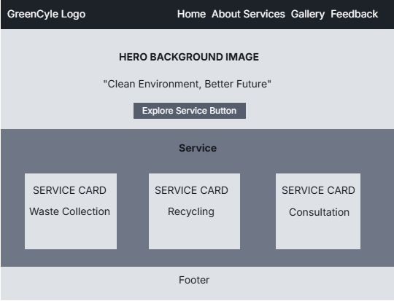
About us page
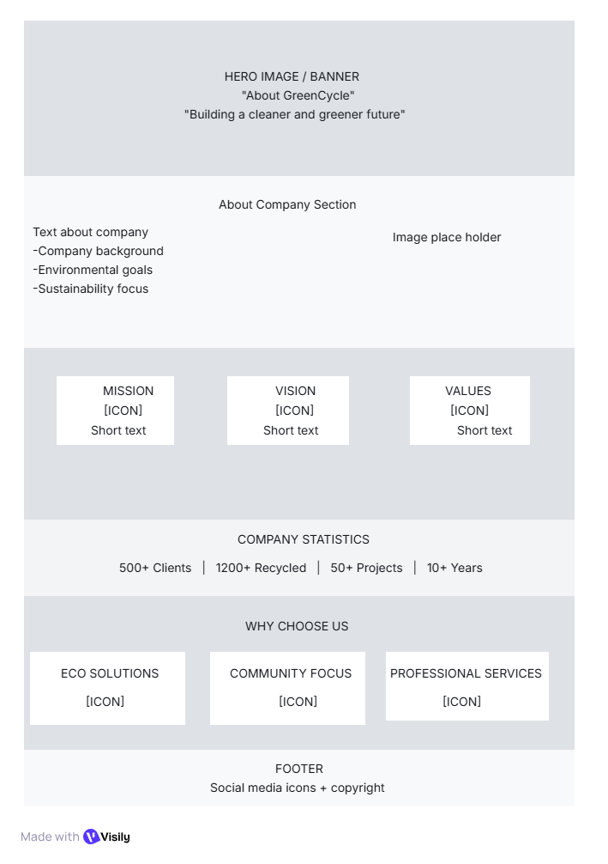

SERVICE PAGE
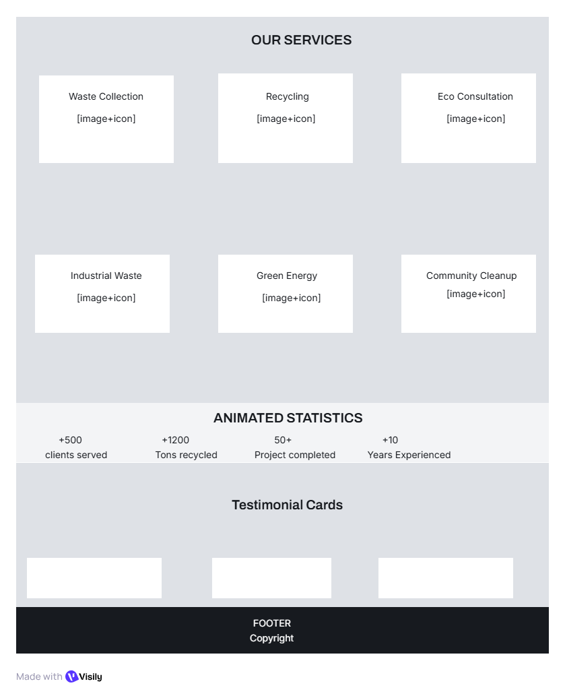
GALLERY PAGE
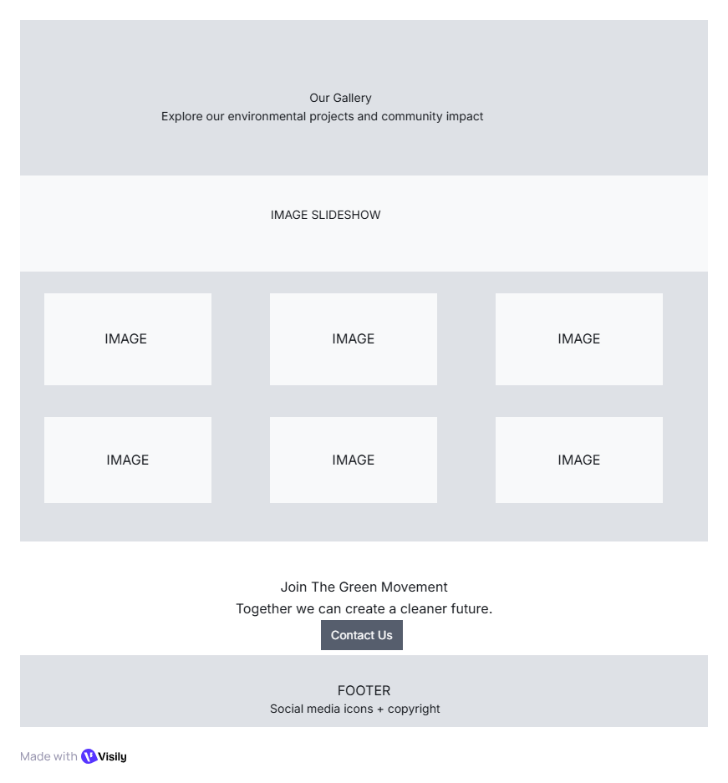
FEEDBACK PAGE
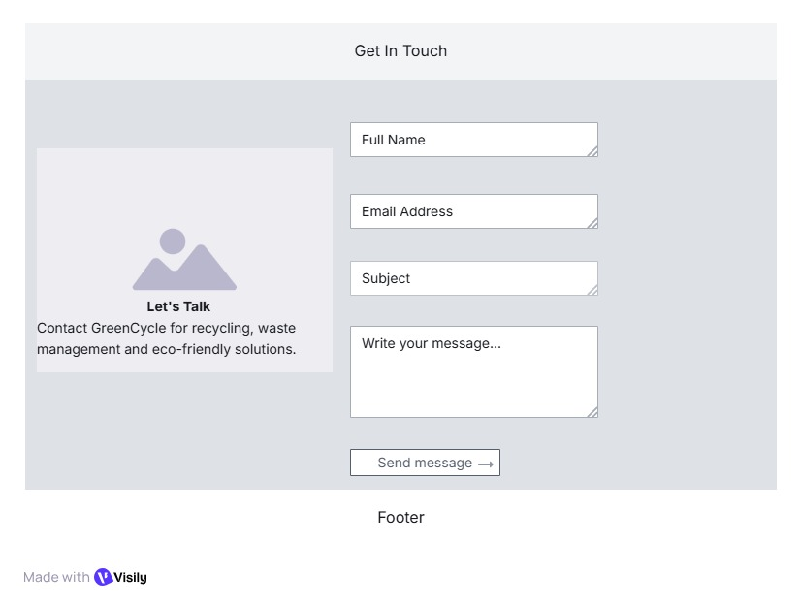

7. TECHNICAL BRIEF
Technologies Used
Technology | Purpose
HTML5 | Structure of the website
CSS3 | Styling and layout
Bootstrap | Responsive design
JavaScript | Interactivity and validation
GitHub Pages | Website hosting
Tools Used
- Visual Studio Code (Code editor)
- GitHub (Version control & hosting)
- Web Browsers (Chrome, Firefox, Edge)
- Image tools (Canva, Pinterest, GIMP)

8. QUALITY ASSURANCE (TESTING)
Browser Testing
The website was tested on:
- Google Chrome
- Mozilla Firefox
- Microsoft Edge
All pages displayed correctly with no layout issues.
Mobile Responsiveness
- Tested on mobile devices using browser developer tools
- Layout adjusts using Bootstrap grid system
- Navigation collapses into mobile menu
Functional Testing
- Navigation links → All working (no broken links)
- Feedback form → Validates required fields
- Images → Load correctly with alt attributes
Screenshots
(Screenshots should be inserted here in your Word document showing testing on different devices and browsers.)

9. PUBLISHING & PROMOTION
Hosting Method
The website is hosted using GitHub Pages, a free web hosting service.
GitHub Process
Commands used:
git init
git add .
git commit -m "Initial commit"
git branch -M main
git remote add origin https://github.com/username/repository.git
git push -u origin main
Live Website URL
https://kevinrony.github.io/cse25-391/
Repository URL
https://github.com/Kevinrony/cse25-391
10. FUTURE DEVELOPMENTS
The website can be improved by:
- Adding online payment integration
- Implementing user accounts and login system
- Adding live chat support
- Enhancing animations and UI effects
- Integrating a real booking system with database

11. CONCLUSION
The GreenCycle website was successfully designed and developed following modern web development practices. It meets all assignment requirements, including responsiveness, usability, and functionality. The project demonstrates strong understanding of HTML, CSS, Bootstrap, and website planning processes.

12. REFERENCES
- W3Schools (https://www.w3schools.com)
- Bootstrap Documentation (https://getbootstrap.com)
- MDN Web Docs (https://developer.mozilla.org)

